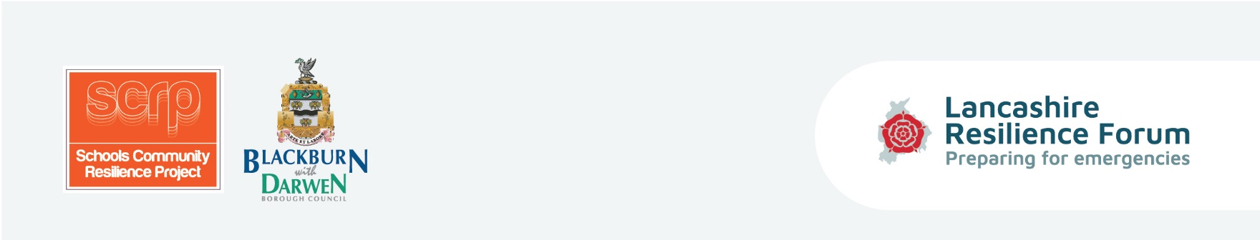
Equipping children and parents with the tools and coping strategies to be prepared in the event of an emergency situation and to enhance self-resilience within Lancashire’s communities.

Session Two Lesson Plan - What if…? Research Time
Curriculum/Cross-curricular: |  | Year group:
Objectives | Develop an understanding of the roles of emergency responders and awareness of  weather warnings.
Learning outcomes | Be able to demonstrate objectives above through role play/show and tell.
Homework | Find a news story involving one or more of the emergency services.
Learning episodes -  Teacher or student led | Research all 4 agencies, watch agency videos and utilise the web links in the  guidance cards. Task the children to research one emergency agency in groups and  dress up.  Complete ‘roles-writing frames’ to role play the agency they have researched.  Task the children to research the Met Office & EA - play the games and look at  symbols, warnings and alerts in the video. Utilise Guidance card 4 for games and  quiz links.  Task the children to explain what the different symbols mean.
Differentiation | Based on ability the activities can be adapted accordingly and extra support will be  on hand from Teacher and Teaching Assistant.
Engagement? | Team player? Independent enquirer? Peer engagement? Effective participant?
Key words | Met Office, Environment Agency (EA), warnings, alerts, symbols, Local Authority  (LA), hazards, British Red Cross, North West Ambulance Service (NWAS), Lancashire  Fire and Rescue Service (LFRS), responder, rest centre, diversions, debris, resilience.
Plenary/AFL | Role play/Show and tell.

Activities | Tick if used

Research time for children - watch videos (Fire and Ambulance resource, LA web based information)/research all 4 agencies/use resource pack as necessary (teachers) - Complete ‘Roles - writing frames’ using Guidance card 3.

In groups, research specific agency and then do Show & Tell to other groups (possible role play) Guidance card 3 details key messages from each of 4 services.

Interactive Games online - What If? - explore What If? resources and links on Guidance card 4.

Research Met Office symbols/play game (Guidance cards 5 and 5a teachers prompt sheet)

Task: Question: ‘What issues do children think they face on a day to day basis or on holidays?’ photocopy pictures for circling hazards game.

Resources | Instructions | Tick if used
British Red Cross PowerPoint:  1. Winter preparedness games | Any/all can be photocopied and circulated to the children for ‘fun learning’.
2. Winter weather
EA - Clear Plan leaflet
EA – Clear Plan video | See Guidance card 5a
NWAS - Information on ‘How to call for an Ambulance’
NWAS - Test for the above
NWAS - Test on ‘Little or Big accidents’
What If..? pictures of various emergencies
Roles - writing frames for all 4 agencies | To circulate to children.
Guidance cards
3 | Roles and Research of Local Authority and Emergency Services
4 | Web links for interactive games and online quizzes
5 | Met Office weather & EA prompt sheet
5 a | Environment Agency website & resources

