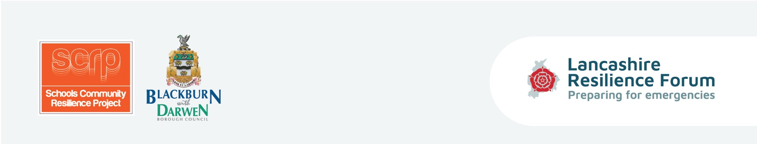
Equipping children and parents with the tools and coping strategies to be prepared in the event of an emergency situation and to enhance self-resilience within Lancashire’s communities.

Session Six Lesson Plan - Show and Tell Assembly
Curriculum/Cross-curricular: |  | Year group:
Objectives | Role play agencies’ responses to scenarios to demonstrate understanding of what  the agencies do. Announce competition winners and award prizes
Learning outcomes | Be able to demonstrate through the assembly and display board the role agencies  play in response to emergency scenarios .
Homework | Ask pupils to complete Post course questionnaire and return to teacher.
Learning episodes -  Teacher or student led? | Task the children to role play the scenarios - by asking the question and asking what  do you think the emergency services and local authority would do?  Announce the 5 competition winners and ask the winners to explain their exhibits.  Further extension of cross-curricular activity from previous session if time permits –  see prompt sheet.  Task the children to complete the post questionnaire and use to benchmark what  they have learnt.
Differentiation | Based on ability the activities can be adapted accordingly and extra support will be  on hand from teacher and teaching assistant.
Engagement? | Team player? Independent enquirer? Peer engagement? Effective participant?
Key words | Scenarios, prompts, investigate, journey, crash site.
Plenary/AFL | Assembly and display board. Post course questionnaire

Activities | Tick if used

• • Role play scenarios questions (Guidance card 10)

• • Competition final – poster/poem/short story/song…5 winning children to present their competition entry and explain why they chose that format to demonstrate their learning regarding What is an emergency? Prize is “grab bag” with goodies – 2 winners and 3 runners up.

• Suggest display of all competition entries to the rest of school.

• Post course questionnaire given to children to complete and hand in to teacher.

Resources | Instructions | Tick if used
Prizes | To be awarded to winning children by headteacher.
Post course questionnaire  (to be compared to Pre course questionnaires to demonstrate acquired learning) | Essential to circulate to children for completion and collection.
Guidance cards
10 | Role Play scenario – prompt sheet
11 | Grab bag prize content - information

