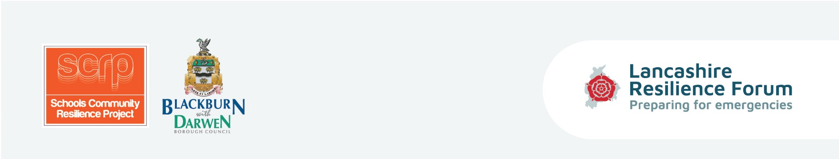
Equipping children and parents with the tools and coping strategies to be prepared in the event of an emergency situation and to enhance self-resilience within Lancashire’s communities.

Session One Lesson Plan - What is an Emergency?
Curriculum/Cross-curricular: |  | Year group:
Objectives | Develop an understanding of what an emergency is and how to prepare  Understand the correct 999 procedures.
Learning outcomes | Identify and be aware of emergency situations.
Introduction/homework | Pupils to fill in Pre course questionnaires in class, with support if needed. File to  compare to Post course questionnaire at end.
Learning episodes -  Teacher or student led? | Ask the children to shout out types of emergencies.  999 calls hoax or real - thumbs up or down.  Definition of a grab bag.
Differentiation | Based on ability the activities can be adapted accordingly with extra support from  teacher and teaching assistant.
Engagement | Team player? Independent enquirer? Peer engagement? Effective participant?
Key words | Hoax, grab bag, emergency, natural disaster, human welfare, environment,  terrorism, security, medication.
Plenary/AFL | What is an emergency? Worksheet

Activities | Tick if used
• What is an emergency? Teachers to ask children to shout out types of emergencies.
• Recorded emergency calls* - real or not - Thumbs up or thumbs down. (Printed thumbs up and down resource)
• Definition of an emergency Pupils to have group discussions - teacher will have definition, children to provide suggestions of the definition. (Resource: Guidance card 1)
• Grab bags - Games Information about what a grab bag is before the game and then relay game - first team to place useful items in “grab bag”.
- Definition of a grab bag (Guidance card 2).
- A4 sheet with pictures of what is suitable for a grab bag. Children to discuss in groups before relay.
- Teacher to organise the relay game with relay cards and box/bucket/bag.
- Review contents of bag/box/feedback from each group: discussion, negotiation, quick thinking.

Resources | Instructions | Tick if used
Pre course questionnaire (to demonstrate existing knowledge) | Circulate to children for complete for teacher to collect.
Grab bag worksheet | Circulate to children.
Pictures for the grab bag relay game | Cut in half and laminate.
Audio recordings | Play to children with ‘thumbs up and thumbs down’ resource.
Thumbs up, Thumbs down | Print and circulate to children.
What is an Emergency? Worksheet | Circulate to children to complete.
Guidance cards
1 | What is an emergency? definition
2 | Emergency grab bag prompts

*Please note - All of the Emergency 999 phone calls are based upon real calls/hoax calls received to the 999 number. However, they are voiced by actors to protect and maintain confidentiality.

