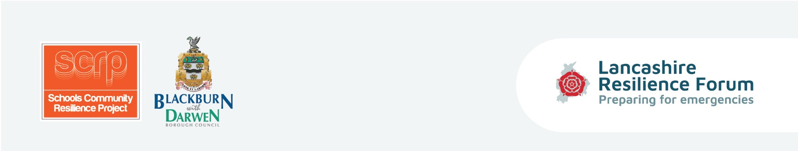
Equipping children and parents with the tools and coping strategies to be prepared in the event of an emergency situation and to enhance self-resilience within Lancashire’s communities.
‘
Session Four Lesson Plan - Home Emergency Plan
Curriculum/Cross-curricular: |  | Year group:
Objectives | Understand what children and families can do to prepare for an emergency.
Learning outcomes | Pupils to be able to develop/complete/fill-in the Home Emergency Plan’ using  feedback from the Home Survey and class discussion.
Homework | Children to take draft plan home and complete part 2 with their family for own use.
Learning episodes -  Teacher or student led? | Task ‘What can I do?’ - review Home Survey homework through class discussion,  which will support any pupils who have not completed the homework.  Consider home-based scenario to encourage development of a Home Emergency  Plan.  Children to think about safe meeting places, what telephone numbers they need to  know, reviewing contents of grab bag. Start the plan.
Differentiation | Based on ability the activities can be adapted accordingly and extra support will be  On hand from teacher and teaching assistant.
Engagement? | Team player? Independent enquirer? Peer engagement? Effective participant?
Key words | Survey, home emergency plan, scenario.
Plenary/AFL | Completion of Home Emergency Plan.

Activities | Tick if used

• What can I do? Review Session 3 homework and develop basic personal Home Emergency Plan.

• Consider home based scenario - to encourage the development of the Home Emergency Plan:

- House flooding

- Loss of power - no heat or light or cooking

• Pupils to use the Home Survey homework and class discussions to help them develop, complete

and fill in the Home Emergency Plan in class. Actions:

Children to come up with the home emergency plan.

Have a safe meeting place/make sure they know what numbers to ring - 999/home number etc./review contents of grab bag/box.

• Competition preparation time

• Home family activity: children to take home the basic Home Emergency Plan with part one completed by them part two to be completed with their family for their use - not to be returned to school.

Resources | Instructions | Tick if used
Home Emergency plan  (template) | To circulate to children (as an example if they have created their own, or to complete).
Escape Plan Maker/Action plan Checklist | To help children with Home Emergency Plan.
Guidance cards
8 | Home Emergency Plan and grab bag prompts
9 | Example Home Emergency Plan

