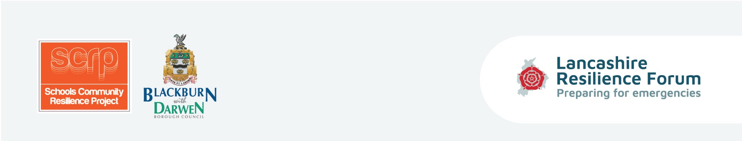
Equipping children and parents with the tools and coping strategies to be prepared in the event of an emergency situation and to enhance self-resilience within Lancashire’s communities.

Session Five Lesson Plan - Question Time
Curriculum/Cross-curricular: |  | Year group:
Objectives | Host a Question Time session using video clips. Take advantage of cross-curricular  learning opportunity by viewing answers to emergency-related questions from the  responding agencies. Competition entries submitted.
Learning outcomes | Pupils to be able to explain what they have learnt through the process of preparing  and submitting their competition entries.
Homework
Learning episodes -  Teacher or student led? | Host question time event using video clips. Teacher to provide pre-prepared  questions and choose which pupils to ask questions with a ‘lucky dip’.  Cross-curricular learning - see prompt sheets (geography - flooding risks, hotspots,  international events, Tsunamis/History - Great Storm, snow/Science – temperature  etc.) research and discussions.  Submit competition entries and select top 5 prizes. Pupils to explain what they  have done and why and what they have learnt.
Differentiation | Based on ability the activities can be adapted accordingly and extra support will be  on hand from teacher and teaching assistant.
Engagement? | Team player? Independent enquirer? Peer engagement? Effective participant?
Key words | Rest centre, risks, hotspots, international events, tsunamis, temperature, Great  Storm.
Plenary/AFL | Pupils to explain what they have done and why for the competition and what they  have learnt.

Activities | Tick if used

• Cross-curricular learning opportunity - prompt sheets (Geography - where would you choose for a rest centre?, flooding risks and hotspots, international events Tsunamis etc. history - Great Storm, East Coast snow, Science - temperatures, Art - logos, Literacy and Numeracy).

• Question Time - Watch videos from emergency services and Local Authority using questions prepared by teacher for pupils.
• Submit competition entries - teacher to select top 5 winners, (2 grab bag prizes and 3 smaller gifts). [Teachers could extend this to week 6 if more time is needed].

Resources | Instructions | Tick if used
Prompts about cross-curricular examples/research events etc. | Prompts for teachers - not to circulate.
Videos | Choose selected from list of video links provided.
Guidance cards - none

