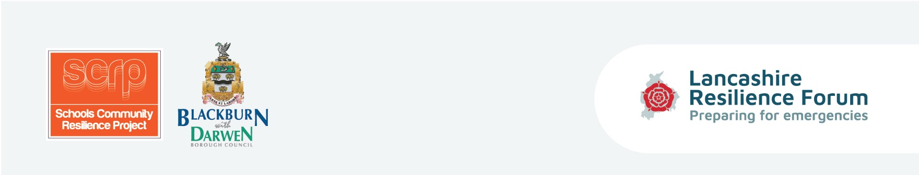
Equipping children and parents with the tools and coping strategies to be prepared in the event of an emergency situation and to enhance self-resilience within Lancashire’s communities.

Session (number) Lesson Plan – (name)
Curriculum/Cross-curricular: |  | Year group:
Objectives
Learning outcomes
Homework
Learning episodes -
Teacher or student led
Differentiation
Engagement?
Key words
Plenary/AFL

Activities – | Tick if used

Resources | Instructions | Tick if used
Guidance cards

