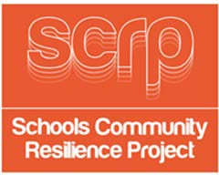
SESSION 2 GUIDANCE CARD 5

Teachers Prompt – Severe Weather

There are five symbols that the Met Office uses to describe weather in easily recognisable pictures.

These are listed below:

Rain


Snow


Ice


Wind


Fog


You will have seen on the weather forecasts that these are presented in colours according to how probable and how severe the weather will be.

Yellow – Be Aware Amber – Be Prepared Red – Take Action

Activity
You could ask children to look at the weather today in groups and make a weather forecast using these symbols to present to other groups; then get them to check the Met Office website to see if it matches the official weather forecast for the Blackburn area.

Met Office weather - http://www.metoffice.gov.uk/

