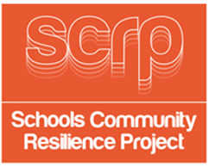
SESSION 3
GUIDANCE CARD 7

Introduction to competition

Introduction to competition – start the competition for the students to demonstrate their learning, over the six sessions, of what is an emergency.

Suggestions:
- Poster
- Poem
- Short story
- Song
- Film
- Interview
- News report
- Vlog



