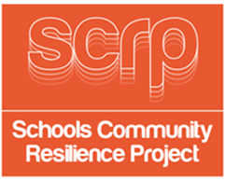
SESSION 6
GUIDANCE CARD 11

Suggested Grab Bag prizes

Contents of Grab bags for 2 winners
- Drawstring bag
- Pencil
- Notepad
- Wind up torch
- Water bottle
- Bottle of water
- Protein/energy bar
- Small pack of sweets
- Superhero stickers

Contents of Grab bag for 3 runners up
- Drawstring bag
- Pencil
- Bottle of water
- Small pack of sweets
- Superhero stickers



